**Forward**

The project contains face recognition model. To install face recognition model, user must install dlib, Cmake and boost first. The attachment “face_recognition” contains installation packages for dlib, Cmake and boost.

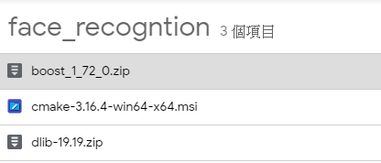

**Installation**

1. Download project and requirement file

$ git clone <https://github.com/jaywong966/Smart-Home-Control-v2.0.git> (This step is not needed if you get it on DVD)

<https://drive.google.com/file/d/1ma8e1EdU89hKlzfItkMzA88n3_eEFTRe/view?usp=sharing> ----Installation package

<https://drive.google.com/file/d/1vfRpQ3feUDNvEzO1CtgvnvSKcgmyvphy/view?usp=sharing> ----Models folder

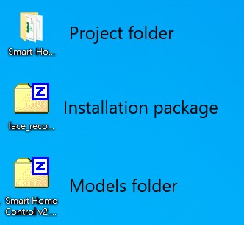

1. Unzip models folder to project folder (**Smart Home Control v2.0.zip**)

(This step is not needed if you get it on DVD)

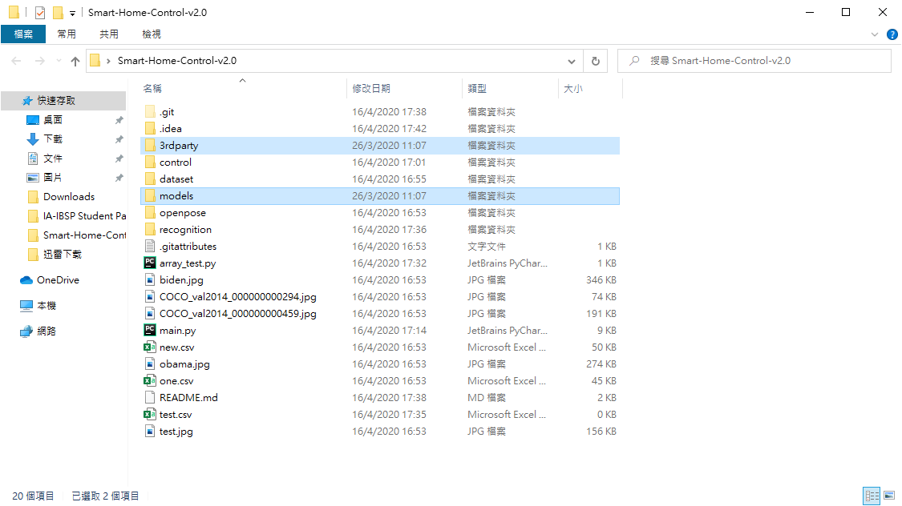

1. Create a new environment call “SmartHome” in Anaconda.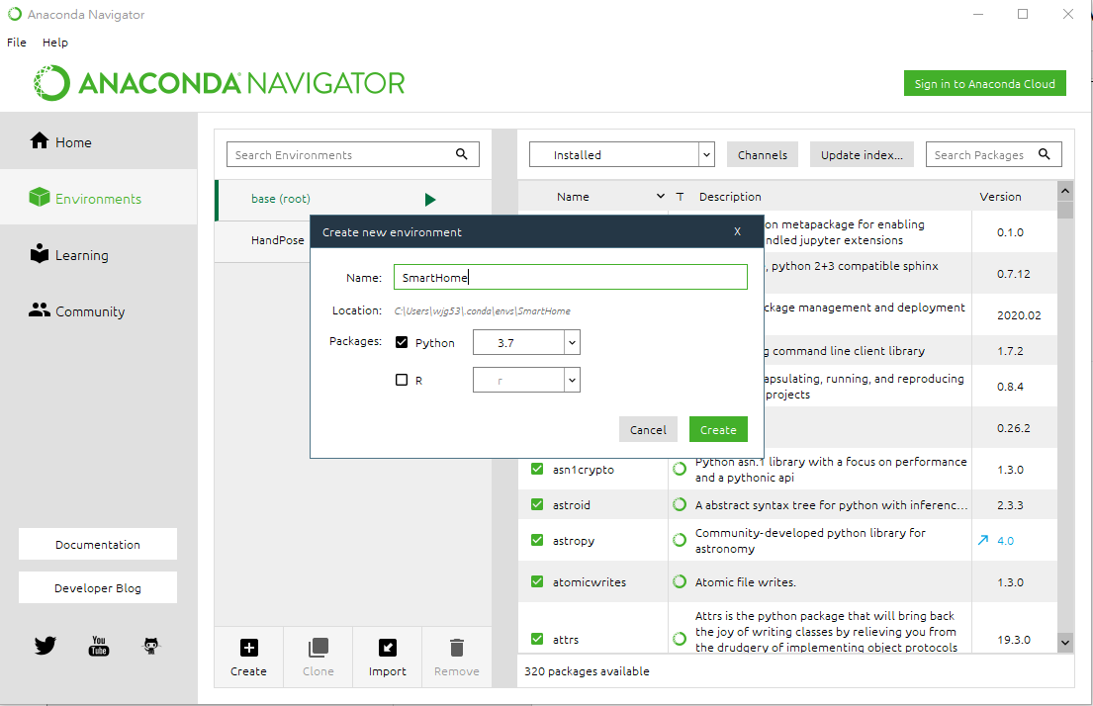
2. Unzip **face_recongnition.zip**, and install **cmake-3.16.4-win64-x64.msi**

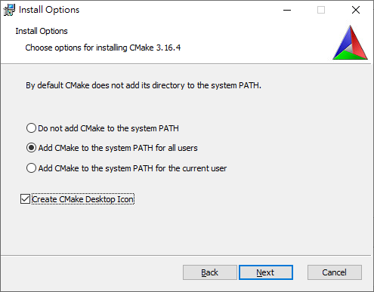

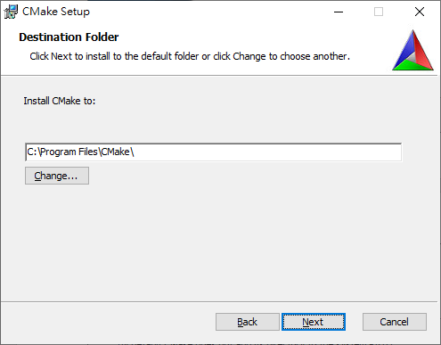

1. Unzip **dlib-19.19.zip** and **boost_1_72_0.zip** to C:\

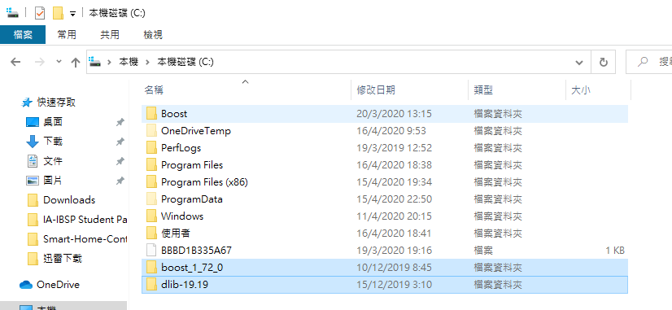

1. Open Anaconda Powershell run $ conda activate SmartHome

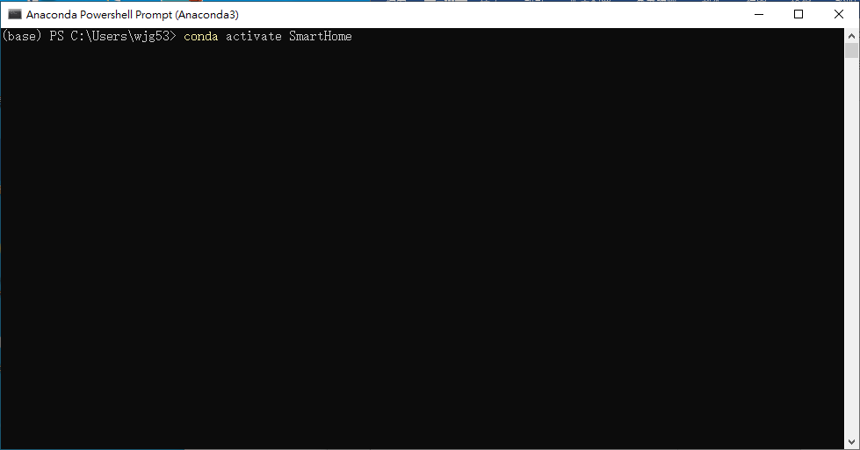

1. Enter command

$ cd C:\dlib-19.19

$ python setup.py install (wait until finish installation)

$ cd C:\boost_1_72_0

$ bootstrap.bat

$ b2 install

$ b2 -a --with-python address-model=64 toolset=msvc runtime-link=static

$ pip install face_recognition

$ pip install sklearn

$ pip install opencv-python

1. Install CUDA and Cudnn

Download CUDA Toolkit 10.0

<https://developer.nvidia.com/cuda-10.0-download-archive?target_os=Windows&target_arch=x86_64&target_version=10&target_type=exenetwork>

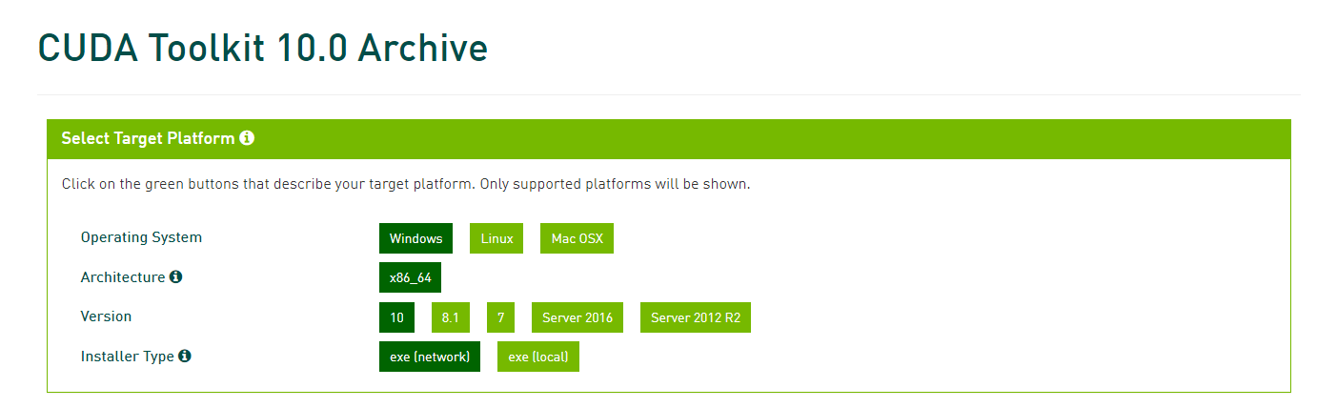

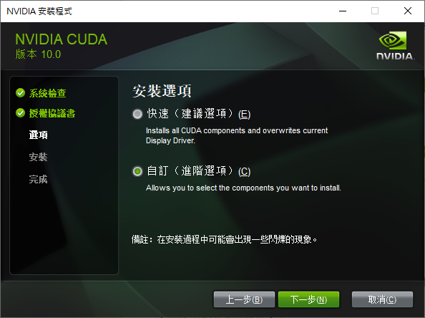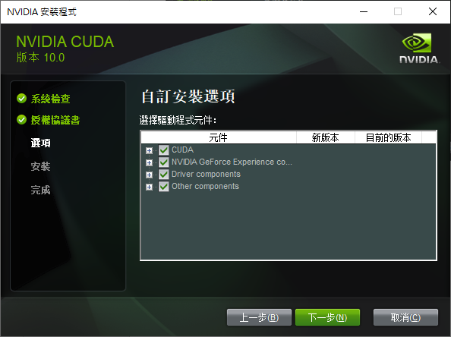

Download Cudnn and unzip it.

<https://developer.nvidia.com/rdp/cudnn-archive>

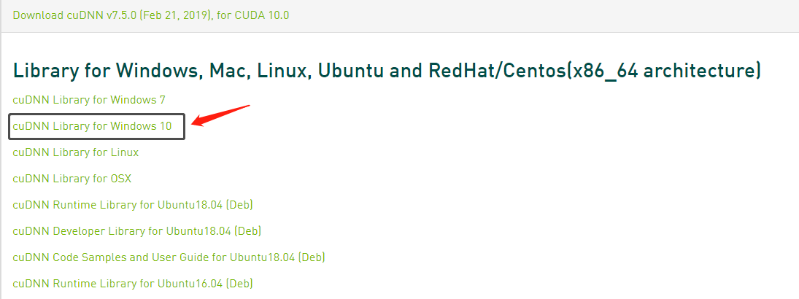

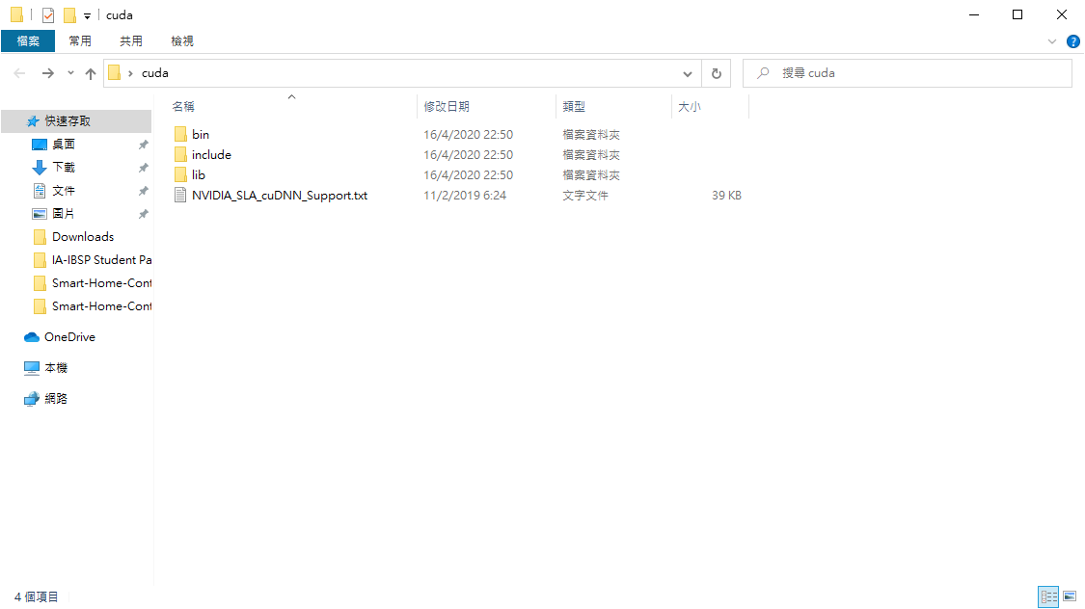 Move all those files into C:\Program Files\NVIDIA GPU Computing Toolkit\CUDA\v10.0

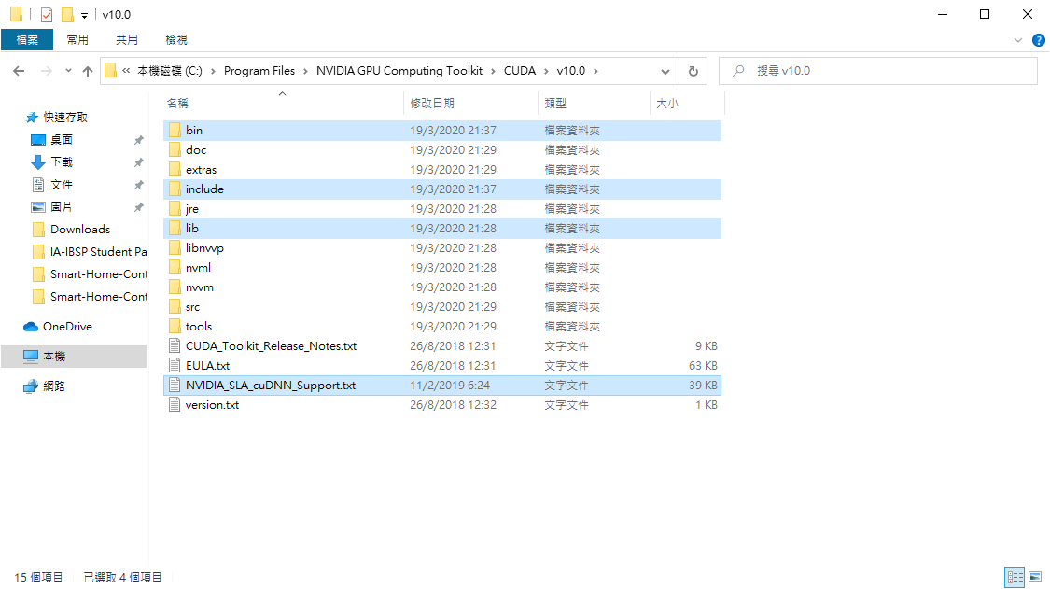

1. Open Spyder (SmartHome)

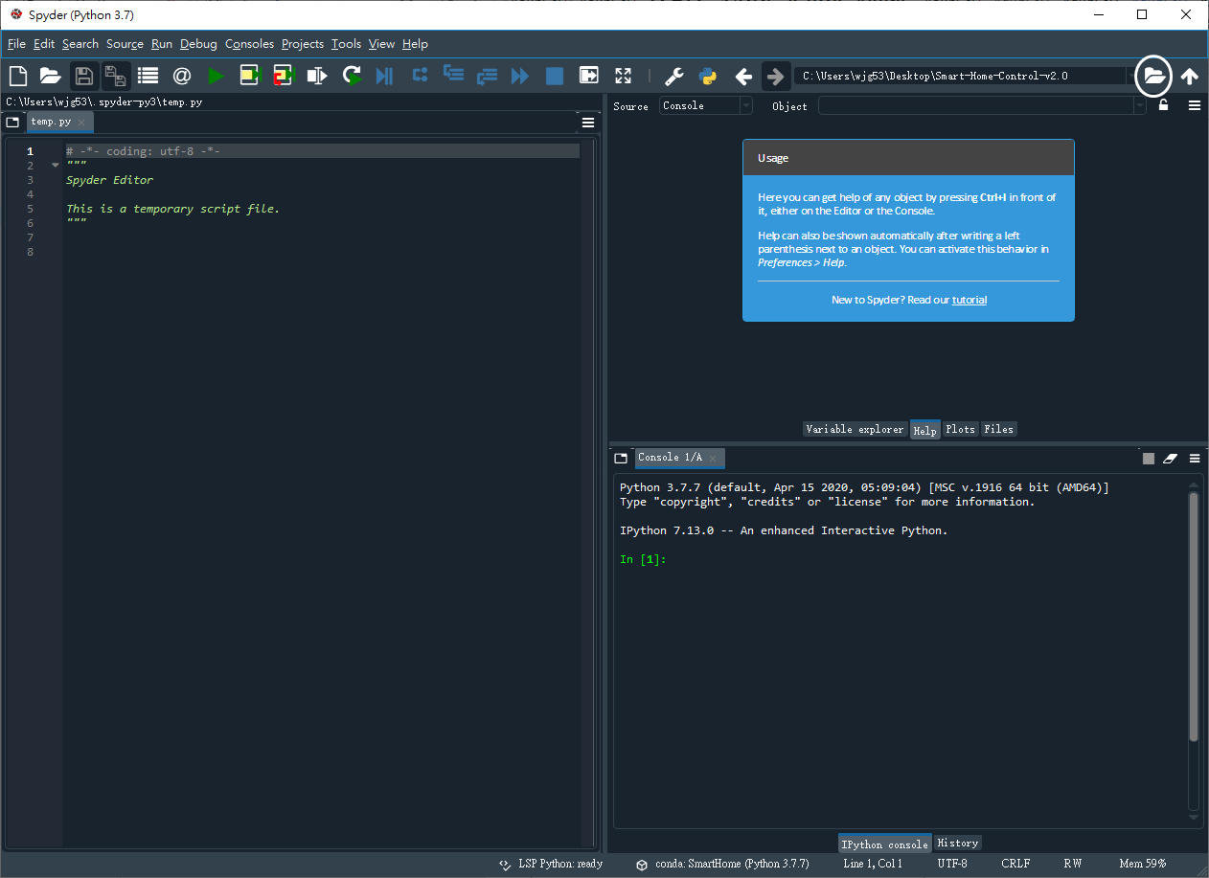

Choose the project folder

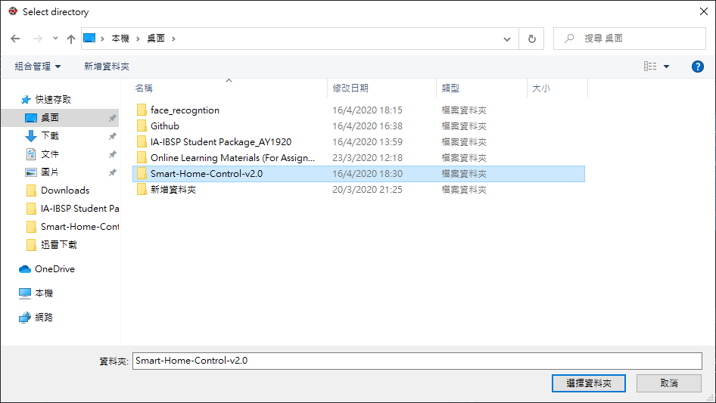

Open main.py and run (F5)